# Report for Gavin Cable (2024-10-01 to 2024-10-31)

Average Bat Speed: 42.34

Average Rotational Acceleration: 6.84

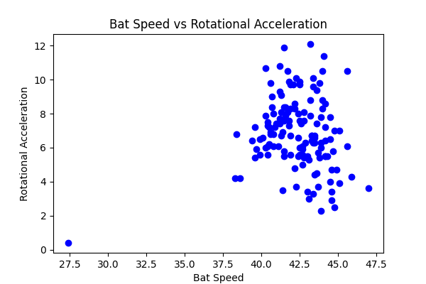

## Comments

Add comments here...